Configuring TIBCO EMS: Fault-Tolerant and Load-Balanced
This Document is intended to give the reader insight into the configurations necessary to achieve Fault-Tolerance and Load-Balancing with TIBCO Enterprise Message System (TIBCO EMS) without the use of specialized hardware. This Document is not intended to convey Best-Practices, but rather how to achieve the product-specific goals of Fault-Tolerance and Load-Balancing.
Version 1.4
Draft
2-Mar-2005
KB106227
Table of Contents
Overview 3
Client Process 4
Fault Tolerant Configuration 5
Configure the Daemon 5
Configure a Fault-Tolerant Factory 7
Set track_message_ids Parameter 7
Starting a Fault-Tolerant Pair 7
Monitoring a Fault-Tolerant Pair 8
Load-Balanced Configuration 8
Configure the Daemon 8
Configure the Load-Balanced Factories (incl. FT pairs) 9
Enable Routing 10
Topics/Queues with Routing 11
Set Global Attribute 11
Round-Robin Queue Consumers 12
JNDI Context URL 12
Testing 13
Simple Fault-Tolerant Test 13
Simple Load-Balanced Test (with FT) 14
Understanding EMS Console Output 15
Testing Using BusinessWorks 17

Overview

In the document, we will configure TIBCO Enterprise Message Service from building a set of fault-tolerant pairs to putting those pairs into a load-balanced environment. The solution can be built on a single machine and tested, as shown below. In a real deployment scenario, you would want to have each machine be distinct.

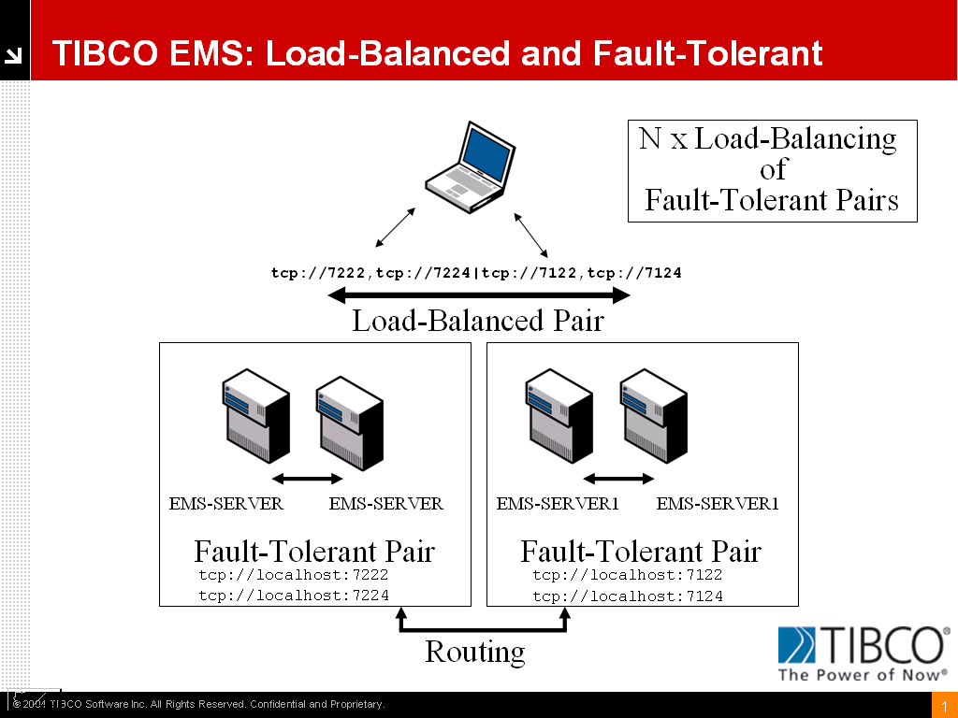

In the diagram above, you see four EMS Server instances with each Fault-Tolerant (FT) pair sharing the same EMS “Server Name”, and you see the client with a complex URL that is constructed such that you have FT pairs separated by a comma and those pairs in a Load-Balanced (LB) arrangement separated by a vertical bar (or pipe symbol). To make this arrangement work on a single machine, the individual services are on distinct ports. The first FT pair has an active server on port 7222 with a backup server listening on port 7224, for example. The primary is the one that starts first.

To make LB work, you need to route between servers, so a new EMS “Server Name” needs to be used, and Topics and Queues need to be routed between these instances. Queues are restricted to a single hop, while Topics can be multi-hop for their routes. Load-Balancing can be across an arbitrary number of servers and need not be in conjunction with Fault-Tolerance.

Overall, we will be configuring the EMS Daemons, configuring appropriate JMS Factories, configuring routes, and creating Topics and Queues.

Client Process
The JMS client will use the JNDI Context URL to retrieve one or more Factory objects. The Factory object will contain the URL(s) and other elements necessary to implement either Fault-Tolerance, Load-Balancing, or both. The URL syntax will determine FT/LB semantics, and if there is Load-Balancing, then an element that defines a metric will also be returned. Depending on the model, the client then makes its connection. In the case of Load-Balancing, it will query each Provider to obtain the information pertinent to the chosen metric, and then connect based on the returned information.

Fault Tolerant Configuration

Configure the Daemon
To configure Fault-Tolerance, we will need to configure only two types of files:
- tibemsd.conf – configure the daemon process
- factories.conf - build FT factories as needed
Since we have a FT pair, we will create two files for the daemon processes so that we can start them with different configurations on the same machine. Given different machines, each machine will only need one of each of the types of files, but for our example, some types of files are shared while others need to be replicated to provide unique features.

Below, you will see the first tibemsd.conf file, renamed tibemsd1.conf to provide a unique identity. Note the bold items for server, store, listen, and ft_active – these are the required entries for FT configuration; the addition of the routing item is included at this time since we will be using this FT pair in an LB environment. The basic concept is that a FT pair shares the server name for JNDI lookup, they share the storage to provide message context and configuration, and they share listen and ft_active, but in a “flip/flop” manner, where these two values are swapped.

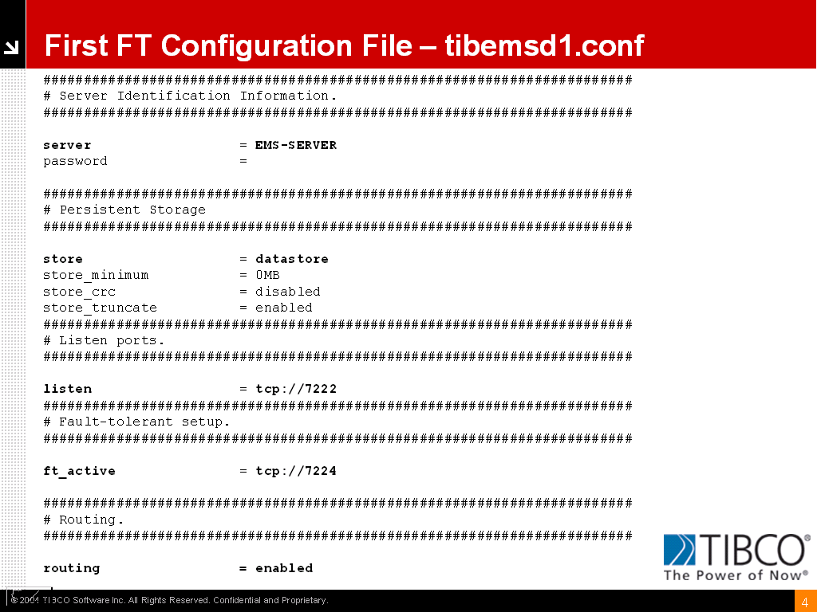

The second configuration will be accomplished by making a copy of the first and renaming it, prior to making some minor modifications. In the example below, we have named the file tibemsd2.conf:
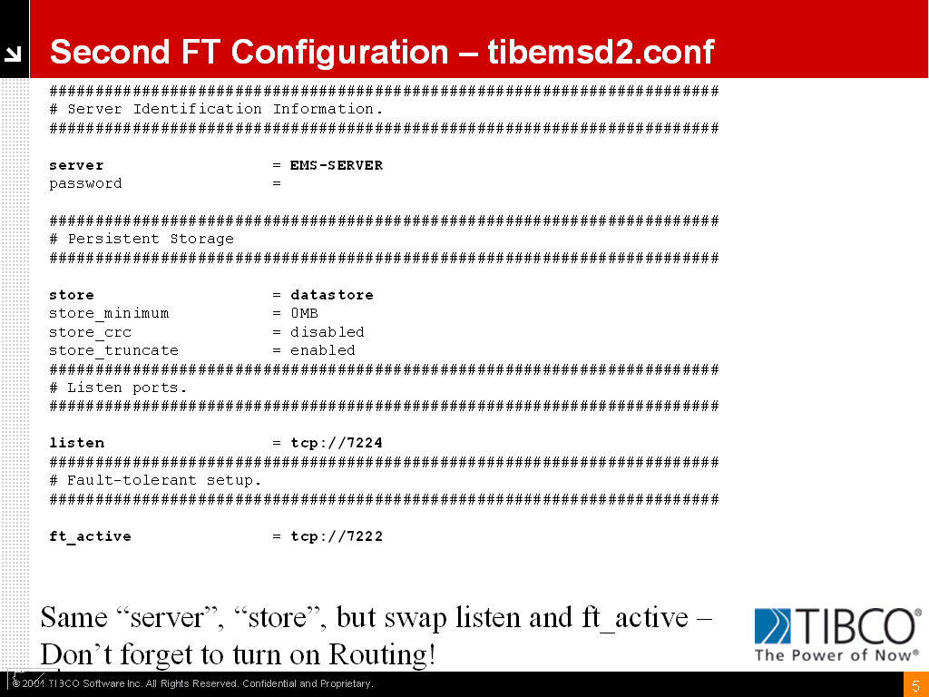

Note how the ft_active port is the same as the listen port of the other configuration, and vice versa! This is the only change necessary. This is akin to a “roll-over” cable and permits each server to receive heartbeats from the other. The active server has an exclusive lock on the storage.

Configure a Fault-Tolerant Factory
Edit factories.conf and create two factories, one for queues and one for topics. The standard factories.conf come with these preconfigured as FTTopicConnectionFactory and FTQueueConnectionFactory. The syntax in the file looks like this:

[FTTopicConnectionFactory]
type = topic
url = tcp://localhost:7222,tcp://localhost:7224

[FTQueueConnectionFactory]
type = queue
url = tcp://localhost:7222,tcp://localhost:7224

An alternate method to editing this file is to start up one of these daemons and to access the EMS Administration Tool and enter the command:

create factory FTQ queue url=tcp://localhost:7222,tcp://localhost:7224

This will create a ConnectionFactory for queues that exposes a Fault-Tolerant URL, as shown by the two comma-separated host specific URLs. When a Client requests the FTQ factory object through JNDI, it will have this complex URL associated with these two servers.

Set track_message_ids Parameter

There will be Fault-Tolerant cases where a failure occurs before the Provider can acknowledge the receipt of the message, so to prevent duplicate messages, you set the track_message_ids parameter in the tibemsd.conf file:

track_message_ids = enabled

Starting a Fault-Tolerant Pair

Simply start two instances of the EMS daemon where each instance points to a specific configuration file (shown is from a Windows Batch file):

start tibemsd -config tibemsd1.conf
start tibemsd –config tibemsd2.conf

Monitoring a Fault-Tolerant Pair

The EMS Administration Tool needs to connect to a particular instance, so start the Tool and for the connect string enter:

connect tcp://localhost:7222

Start up another instance, and change the connect string to:

connect tcp://localhost:7224

In this manner you will be able to see a client fail-over by issuing the “show connections” command.

Load-Balanced Configuration

Configure the Daemon
You can start with one of the existing tibemsd.conf files and you will need to modify the server, store, listen, ft_active, routing and routes elements.

Server is the name of the EMS Server, and it needs to be distinct from other members of the LB group. In this case, we have chosen EMS-SERVER1. Since we will be building everything on a single host with two LB members each in a FT pair, we need to create another FT pair. In this case, we are using ports 7122 and 7124 with server EMS-SERVER1, a new store, and a new routes element (more on routes later).

The configuration approach is the same for building a FT Pair, by swapping listen and ft_active ports. The difference is that this is a new instance of FT and needs a unique name and storage. Routes need to be different as one cannot route to oneself.

The parameters we will use are as follows:

server = EMS-SERVER1
store = datastorelb
listen = tcp://7122
ft_active = tcp://7124
routing = enabled
routes = routes2.conf

Configure the Load-Balanced Factories (incl. FT pairs)

In a similar fashion, you can edit the factories.conf file or enter the new factories via the EMS Administration Tool. The difference is the syntax where a vertical bar, or pipe, is used to delimit the two fault-tolerant pairs.

[LBTopicConnectionFactory]
type = topic
url = tcp://7222,tcp://7224|tcp://7122,tcp://7124
metric = connections

[LBQueueConnectionFactory]
type = queue
url = tcp://7222,tcp://7224|tcp://7122,tcp://7124
metric = connections

These URLs combine FT and LB. With Load-Balancing, you have the element of metric which can be either connections or byte_rate. The client will retrieve the URL based on request of a particular Factory, and if it is a load-balanced URL, it will query each participant for the value of the metric and the client will make the connection appropriate to the metric.

URL Matrix
Type | URL
Simple | tcp://host:port
FT | tcp://host:port,tcp:/host:port
LB | tcp://host:port|tcp://host:port
FT/LB | tcp://host:port,tcp://host:port| tcp://host:port,tcp://host:port

Enable Routing
This section is not an exhaustive look at the capabilities of routing in EMS, but rather a practical look at the requirements of routing in the context of Load-Balancing. You MUST route messages between LB servers, and if using FT pairs, you need to specify a FT URL. As you cannot route to yourself, and keeping in mind that Queues can only have one hop, you must configure routes appropriately.

The routes.conf file for EMS-Server will point to EMS-SERVER1 and use the FT URL for that pair, as follows:

[EMS-SERVER1]
url = tcp://7122,tcp://7124
zone_name = default_mhop_zone
zone_type = mhop

Since we pointed EMS-SERVER1 to routes2.conf, it will look like this:

[EMS-SERVER]
url = tcp://7222,tcp://7224
zone_name = default_mhop_zone
zone_type = mhop

See the EMS documentation for more information on Zones and Zone-types. For this example, we can take the default. These entries can be created through the EMS Adminstration Tool as well:

create route EMS-SERVER1 url=tcp://7122,tcp//7124

Topics/Queues with Routing

Set Global Attribute
The Global Attribute can be applied to both topics and queues and permits messages to flow between members participating in Load Balancing. You can modify existing topics and queues, or when you create new ones, the syntax is as follows:

tcp://localhost:7222> create topic foo.bar global
Topic 'foo.bar' has been created
tcp://localhost:7222> commit
Configuration has been saved
tcp://localhost:7222> show topic foo.bar
Topic: foo.bar
Type: static
Properties: global
JNDI Names: <none>
Bridges: <none>
Consumers: 0
Durable Consumers: 0
Pending Msgs: 0
Pending Msgs Size: 0.0 Kb
Total Inbound Msgs: 0
Total Inbound Bytes: 0.0 Kb
Total Outbound Msgs: 0
Total Outbound Bytes: 0.0 Kb
tcp://localhost:7222>

As Queues can only be “one hop” away, you need to designate a “home”. When you configure a queue on a non-home provider, you point to the home with the following syntax, where you specify the home provider for the queue:

create queue my.queue@<server_name> global

Round-Robin Queue Consumers
If you set up queues as ‘non-exclusive’ queues, then multiple Queue Receivers can consume the messages in a Round-Robin fashion.

To do this with a TIBCO Adapter, you need to make sure you are using Queues, that your Adapter Instances point to the same JMS provider, and that the destination is identical across multiple instances (Advanced Tab in Adapter Services). By default, the underlying SDK of the Adapter will create a non-exclusive queue, and by creating multiple instances, you get multiple clients.

JNDI Context URL
The JNDI Context URL can be configured as a Fault-Tolerant URL, but not a Load-Balanced URL. In this manner, should a new client try to connect to a Fault-Tolerant Server pair where the primary has failed-over to the secondary server, the URL will allow the new client to find the JNDI objects. The JNDI Context URL follows the same syntax in that it uses a comma.

tibjmsnaming://<host>:port,tibjmsnaming://<host>:port

Testing

Simple Fault-Tolerant Test
Compile tibjmsLoadBalancedTopicPublisher.java, which is found in the C:\tibco\ems\samples\java directory. Start up all four of your servers. Run setup in the samples directory and execute the class with the following command line:

java tibjmsLoadBalancedTopicPublisher –servers \ tcp://localhost:7222,tcp://localhost:7224\ tcp://localhost:7122,tcp://localhost:7124

This example creates a factory “on-the-fly” (see the code), and it publishes to the first URL (7222) with a default of 100 messages. Now you can then kill the 7222 server and the client will instantly switch to the other server (7224):

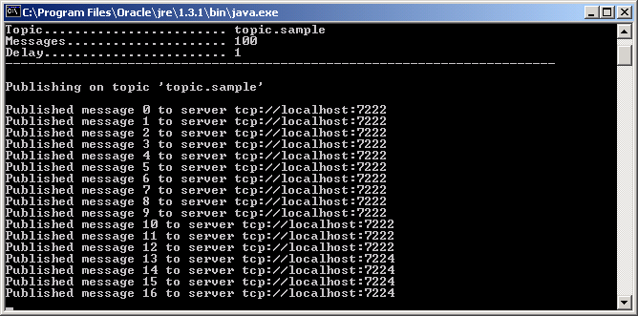

Simple Load-Balanced Test (with FT)
If you run this client a second time, you will see that it picks up the first URL from the second server in the LB scheme, port 7122 (in FT with server on port 7124); as you can see, killing the server on port 7122 causes the client to connect to its FT pair at Message 22:

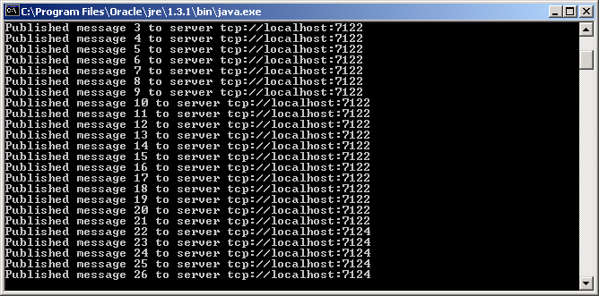

Understanding EMS Console Output
When you start up FT or LB environments, the console output will give you an indication of how things are configured. In the screenshots below, you will see two daemons participating in a Fault-Tolerant configuration.
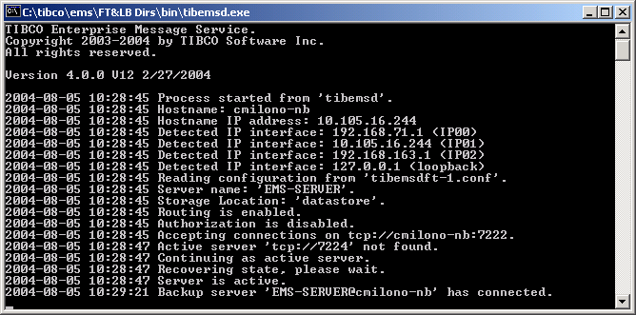
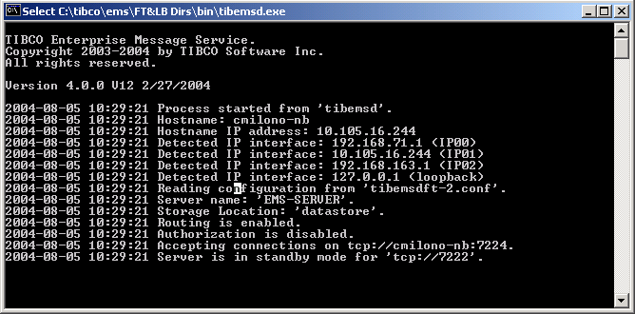

Note on the first screenshot, that “Active server ‘tcp://7224’ not found”, this was true until I started the other daemon shown in the second screenshot, at which point the primary reported that:“Backup server ‘EMS-SERVER@cmilono-nb’ has connected.”
At the same time, the secondary server reports:
“Server is in standby mode for ‘tcp://7222’”
When we start the second set of FT daemons and the routing happens, we see another line in the console output:

Route ‘EMS-SERVER1’ connected to url ‘tcp://localhost;7122’ with zone ‘default_mhop_zone:mhop’.

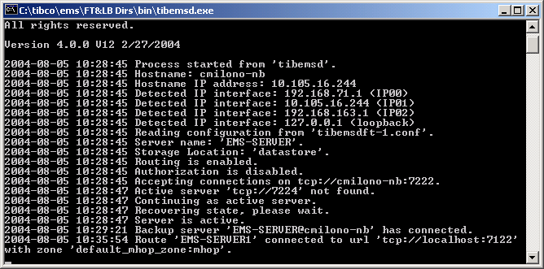

The other server will report:

Route 'EMS-SERVER' accepted from host 'cmilono-nb' with zone 'default_mhop_zone:mhop'.

This shows that the EMS Server “EMS-SERVER” is in route with “EMS-SERVER1”, and that global topics and queues can now flow between the two servers, permitting a functional load-balanced scenario. Without the routes, the clients will still connect in a load-balanced fashion, but the two systems will not behave “as one”.

Testing Using BusinessWorks
Configure the various TRA files to point to the EMS Client libraries – this will ensure that you have the latest Client APIs for compatibility sake.

With BusinessWorks, you will need to create explicit clients, and if you wish to see them distinctly, you can associate a ClientID with each JMS Configuration. Create appropriate Factories, Routes, Topics, and Queues. In this example, in the EMS environments, I created factories called LBQ and LBT, created a Topic called load.balanced and made it a global Topic, and I routed between the LB participants. In BusinessWorks, I created five JMS Connections, each pointing to the same JNDI URL, but having the same factories and each having a unique ClientID (North, South, East, West, Subscriber). I have two processes, one shown below that publishes with four clients, and another which subscribes:

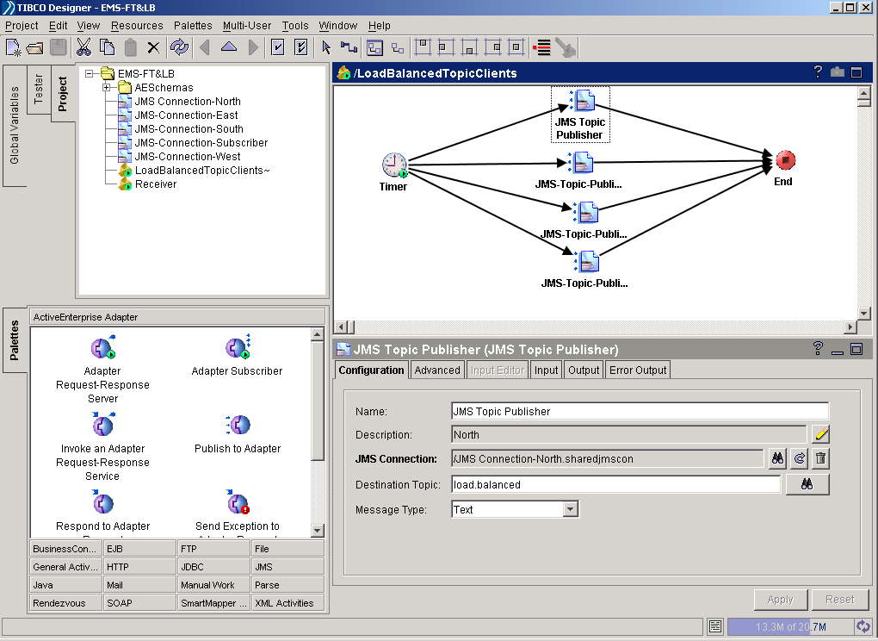

When this runs, all five Clients will be Load-Balanced – if you bring up an instance of the EMS Adminstration Tool, you can “show connections”:

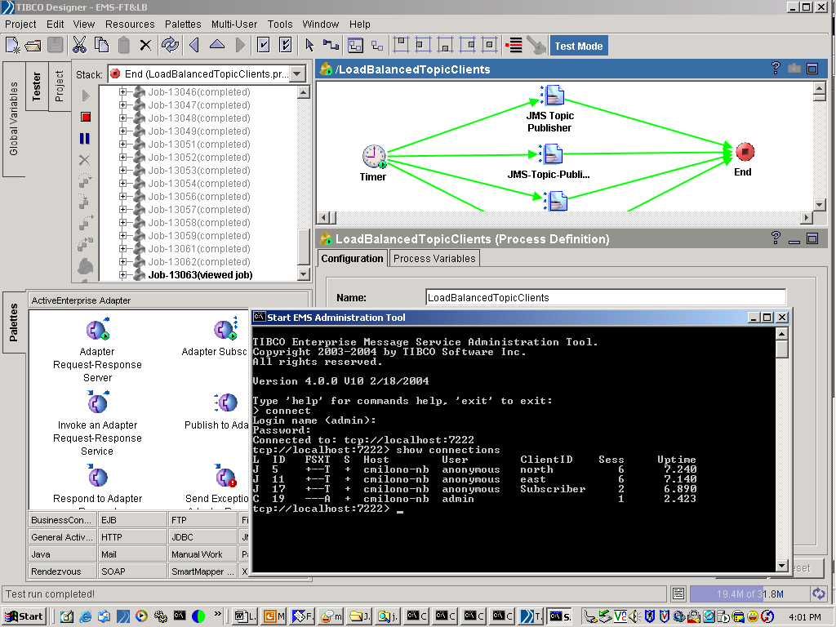

You can start another EMS Administrator Tool, pointing to the other LB participant, and you will see the remaining Clients (South and West, in this case). Kill one or the other (7222 or 7124), and you will see the Clients continue to process their work; restart the appropriate EMS Administration Tool, but with a connection to either 7224 or 7124, and you will see the same Clients.

